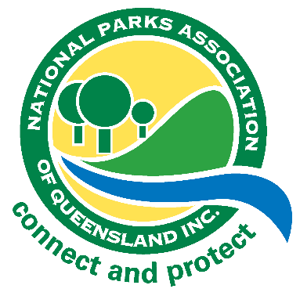
National Parks Association of Queensland
Jim Cuthbertson Grant 2021/2022
Application Form

Date:
Title of project:
Main contact person: Title: First name: Surname:
Mobile number: Other phone:
Co-applicants (if applicable):
Postal address:
Email address:

Please provide a brief overview of your proposed project. Be sure to outline the importance of the project, the type of work being done, where it will take place, and who will be completing the work.

Describe how this project meets at least one of the following requirements:
- improves the conservation value/resilience of one or a number of parks;
- strengthens the science and evidence base of one or a number of parks or park proposals; or
- advances community knowledge of, or connection to, Queensland's national parks.
Explain how this project relates to current issues around national parks and/or your research:

Please detail any other funding that will be received to support this project:

Are there any permits or other approvals required to perform this work? What risks exist, and what will be done to mitigate them (include health & safety, ecological, and other risks)?

Please tell us about your (and any co-applicants) relevant on-ground conservation experience and/or educational background/achievements:

Please return this completed form to admin@npaq.org.au no later than 5pm on 31 March 2021

