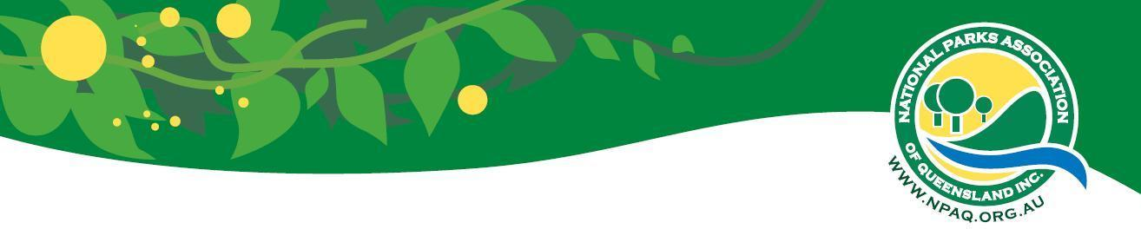
ACTIVITY ATTENDANCE LIST
ACTIVITY: _____________________________________________________________________

DATE: __________________________________LEADER: __________________________________

All Participants in activities organised by the National Parks Association of Queensland Incorporated (NPAQ) participate
at their own risk and are responsible for their own safety. NPAQ accepts no responsibility for any injury that participants may suffer as a result of their participation in activities organised by NPAQ. NPAQ, its Councilors, Activities Committee Organisers and Leaders are not liable in respect of any injury to the person or loss or damage to property, howsoever caused, as a result of participating in the activities organised by NPAQ.

This activity will be conducted in keeping with Queensland Government’s COVID-19 directions at the time of the activity. Please do not attend this activity if you have been feeling unwell with COVID-19 related symptoms in the 7 day period before this activity.

I have read the above disclaimer or had it read to me, with an explanation from the leader about risks and conditions to expect including the proposed route, walk grading, fitness requirements and safety precautions, or that the walk was exploratory, with uncertain conditions and understand its effect, that photographs may be taken and used for promotional purposes, and my signature so attests.

# | NAME (PRINTED) | PHONE:  HOME (H)  WORK (W) | EMERGENCY  PHONE NO. | SIGNATURE | MEMBER  (Yes/no) | FEE PAID  (yes/no) | AGREE TO FACE  PHOTO  (yes/no
1
2
3
4
5
6
7
8
9
10
11
12
13
14
15
16
17
18
19
20
The disclaimer was explained to participants at the start of the activity

LEADER: ………………………………………………………………….……………………………… DATE: …………………………………………………………………

